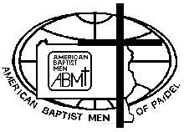

ABMen 2023 Envisioning Retreat Registration
Aug 4-5 Camp Ichthus

Name:__________________________________________________

Address:________________________________________________

Phone Number:___________________________

Email:___________________________________

Home Church:____________________________________________

Pastor:__________________________________________________

Cost of Retreat: $20 payable by cash, check, or online. Deadline: 7/31/23
Please return this registration to :
FBC Bethlehem
3235 Linden Street
Bethlehem PA 18017
For more information contact Pastor David Hardin: dhardin@abcopad.com

